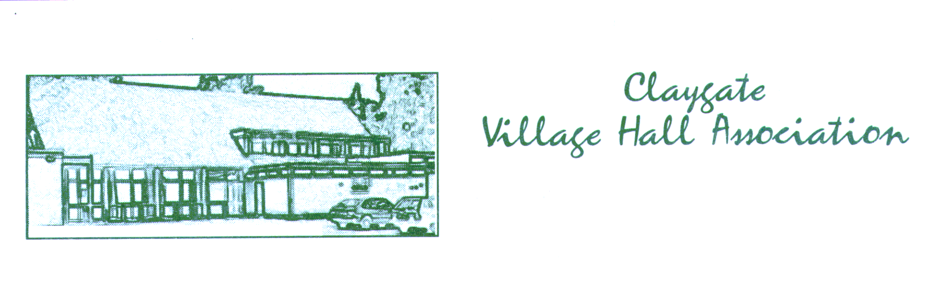
Safeguarding Policy
Registered Charity No., 305007
A Guide to Safeguarding Vulnerable Users
Claygate Village Hall

Introduction
This policy is designed for an infrastructure organisation OR BUILDING which is itself is NOT providing regular activities for vulnerable people BUT still has a clear safeguarding duty to ensure that all the Multi Agency Procedures for Adults and Children are clearly followed and adhered to.

What is a vulnerable user?
Vulnerable users could include:
- children
- young people
- adults with learning difficulties or physical disability
- frail, elderly people.
- Carers
- the safety of those who cannot read warning signs, ie English is not there first language
- or they are not able to speak due to stroke
- or physically less able needs to be borne in mind.
The types of abuse / neglect are set out in the Care Act 2015 as:
Domestic violence | including psychological, physical, sexual, financial, emotional abuse; so called ‘honour’ based violence
Sexual abuse | including rape, indecent exposure, sexual harassment, inappropriate looking or touching, sexual teasing or innuendo, sexual photography, subjection to pornography or witnessing sexual acts, indecent exposure and sexual assault or sexual acts to which the adult has not consented or was pressured into consenting
Psychological abuse | including emotional abuse, threats of harm or abandonment, deprivation of contact, humiliation, blaming, controlling, intimidation, coercion, harassment, verbal abuse, cyber bullying, isolation or unreasonable and unjustified withdrawal of services or supportive networks
Financial or material abuse | including theft, fraud, internet scamming, coercion in relation to an adult’s financial affairs or arrangements, including in connection with wills, property, inheritance or financial transactions, or the misuse or misappropriation of property, possessions or benefits
Modern slavery | encompasses slavery, human trafficking, forced labour and domestic servitude. Traffickers and slave masters use whatever means they have at their disposal to coerce, deceive and force individuals into a life of abuse, servitude and inhumane treatment.
Discriminatory abuse | including forms of harassment, slurs or similar treatment; because of race, gender and gender identity, age, disability, sexual orientation or religion
Organisational abuse | including neglect and poor care practice within an institution or specific care setting such as a hospital or care home, for example, or in relation to care provided in one’s own home. This may range from one off incidents to on-going ill-treatment. It can be through neglect or poor professional practice as a result of the structure, policies, processes and practices within an organisation.
Neglect and acts of omission | including ignoring medical, emotional or physical care needs, failure to provide access to appropriate health, care and support or educational services, the withholding of the necessities of life, such as medication, adequate nutrition and heating.
Self-neglect | this covers a wide range of behaviour neglecting to care for one’s personal hygiene, health or surroundings and includes behaviour such as hoarding.

At any stage you may wish to seek further advice or support from the following sources:
DESIGNATED SAFEGUARDING LEAD FOR CLAYGATE VILLAGE HALL IS;-
NAME: Allan Carruthers
Tel:- 01372 467610
Email: bigalcarruth@hotmail.com

Adult Protection:
SURREY COUNTY COUNCIL;-
http://www.surreycc.gov.uk/social-care-and-health/surrey-safeguarding-adults-board/safeguarding-resources-helpful-information-from-non-surrey-safeguarding-adults-board-sources/surrey-safeguarding-adults-multi-agency-procedures,-information-and-guidance
- Telephone: 0300 200 1005 (8 am-6 pm weekdays)
- Email: contactcentre.adults@surreycc.gov.uk
- Textphone (via Text Relay): 18001 0300 200 1005
- Emergency Duty Team: 01483 517898 (6pm-8am weekdays and 24 hours a day on weekends and bank holidays)
- SMS: 07527 182861
- Fax: 020 8541 7390
- Minicom: 020 8541 9698.

Vulnerable Adults Protection: Action on Elder Abuse – helpline 0808 808 8141
Age Concern – helpline 0800 009966
Child Protection:
http://www.surreycc.gov.uk/social-care-and-health/childrens-social-care/information-for-child-social-care-professionals/surrey-safeguarding-children-board

Contact children's services
If you have concerns about a child you can contact Children's Services - Monday to Friday from 9 am to 5 pm.
Outside of these hours call us on 01483 517898 to speak to our emergency duty team. In an emergency where you are concerned for the child's immediate safety you should call Surrey Police on 999.

Local Referral, Intervention and Assessment Services
Area | Contact number | Email
North East Area  Spelthorne, Elmbridge and Epsom & Ewell | 0300 123 1610* | NERAIS@surreycc.gov.uk  secure email:  nerais@surreycc.gcsx.gov.uk
South East Area  Mole Valley, Reigate & Banstead and Tandridge | 0300 123 1620* | serais@surreycc.gov.uk  secure email:  serais@surreycc.gcsx.gov.uk
North West Area  Runnymede, Surrey Heath and Woking | 0300 123 1630* | nwrais@surreycc.gov.uk  secure email:  nwrais@surreycc.gcsx.gov.uk
South West Area  Guildford & Waverley | 0300 123 1640* | swrais@surreycc.gov.uk  secure email:  swrais@surreycc.gcsx.gov.uk
Emails are dealt with during normal office hours

The Multi-Agency Safeguarding Hub (MASH)
Monday to Friday from 9 am to 5 pm
The Multi Agency Safeguarding Hub responds to initial enquiries about children and young people as a result of Police involvement with the child or their family.
The MASH is based at Guildford Police Station and combines Children's Service social workers and police staff.
Contact Details (taken from the Surrey Matters leaflet dated 1/3/17) are as follows:
- For concerns for a child or young person: csmash@surreycc.gov.uk (For secure email accounts, please use: csmash@surreycc.gcsx.gov.uk)
- For concerns for an adult: ascmash@surreycc.gov.uk (For secure email accounts, please use: ascmash@surreycc.gcsx.gov.uk)
However, if you do not have a MARF and are concerned about the safety of a child, young person or an adult, contact us on 0300 470 9100.

Local Authority Designated Officer (LADO)
Monday to Friday from 9 am to 5 pm
The LADO Service manages allegations against individuals who work or volunteer with children in Surrey. If you have a concern regarding someone who works with children please contact the LADO on 0300 123 1650*or LADO@surreycc.gov.uk.

Surrey Safeguarding Children Board (SSCB)
Monday to Friday from 9 am to 5 pm
The Surrey Safeguarding Children Board co-ordinates how children are safeguarded and protected from harm. The SSCB is based in Leatherhead.
The website Surrey Safeguarding Children Board provides guidance and protocols for professionals as well as details of child protection training courses available.

Useful contacts:
Name | Contact number | Email
SSCB Support Team | 01372 833330 | sscb@surreycc.gov.uk
SSCB Chair | 01372 833378 | SSCBchair@surreycc.gov.uk
SSCB Training | 01372 833917 | sscb.training@surreycc.gov.uk

Child Death
Child deaths should be reported to the SSCB Child death overview panel coordinator:
Name | Contact number | Email
CDOP Co-ordinator | 01372 833319 | CDOP@surreycc.gov.uk

Assessment Consultation Therapy (ACT)
To make a referral or for an initial discussion, please phone 01483 519606 or email act@surreycc.gov.uk.

Other local organisations' contact details
The Surrey Safeguarding Children Board (SSCB) website also includes contact details for other local organisations providing help and support for the family.

NSPCC – www.nspcc.org.uk or 0116 234 7223
NSPCC Child Protection Helpline – 0808 800 5000
Criminal Records Bureau – www.disclosure.gov.uk
Save the Children – www.scfuk.org.uk

Organisational Details
Claygate Village Hall is a community organisation with charity status. It is managed by a Board of Trustees and run by experienced staff.

Claygate Village Hall is held in trust for the use of the residents of Claygate and the neighbouring area and is administered by a Board of Trustees representing local organisations and residents.

Claygate Village Hall provides facilities including 2 halls and a meeting room to local organisations for recreational and educational purposes include stage provision.

This policy applies to users of Claygate Village Hall when they are attending events or seeking our advice around issues.

Details of Staff and Trustees
Detailed list of Trustees and members of the Management committee – See Appendix D.

Designated Trustee: Allan Carruthers
Nominated Trustee: Allan Carruthers
Chairman of Trustees: Allan Carruthers
Treasurer: Michael Elliott
Lettings Manager Katie Ernest
Secretary to Trustees Rosy Treasure
Hall Manager Tony Woolhead

Vulnerable Persons Policy Statement
All staff and volunteers have a duty to safeguard vulnerable users and those who may come into contact with vulnerable users.
They should respond to any concerns they may have regarding the physical, sexual, emotional or psychological safety of a vulnerable person or concerns relating to discriminatory or financial violation or exploitation of a vulnerable person.
This policy is in place to protect all vulnerable persons regardless of gender, ethnicity, disability, sexuality, religion or faith.
Principles
The welfare of the child or vulnerable adult is paramount and is the responsibility of everyone. All children and vulnerable adults, without exception, have the right to protection from abuse, whether physical, verbal, sexual, bullying, exclusion or neglect. Bullying, shouting, physical violence, sexism and racism towards children will not be permitted or tolerated.

Policy Statement
No member of the trustees, helpers or other volunteers or staff will have unsupervised access to children or vulnerable adults unless they have been through the safe recruitment procedure and introductory Child Protection or Vulnerable Adults Protection training.
All suspicions or allegations of abuse against a child will be taken seriously and dealt with speedily and appropriately.
All staff and volunteers will be made aware of this policy, child protection, and vulnerable adult issues, and will be offered introductory training.
A copy of the appendices will be provided to all who request it.
There will be a nominated and named Vulnerable Users representative to who any suspicions or concerns should be reported. This person is Allan Carruthers (see contact details on page 2) who is the Designated Safeguarding Lead (DSL) until January 2019. This will be reviewed to ensure that the policy, training and the DSL role is in current and appropriately qualified.
The management committee will endeavour to keep the events safe for use by children and vulnerable adults. The committee recognises that a higher standard of safety is required where use is made by small children, English is not the first language and those who cannot read safety notices and physically disabled adults.
Safe recruitment processes should be used to appoint staff who will be working with children or vulnerable adults in any kind of activity.
These policies and procedures will be reviewed annually and updated as appropriate in the interim periods as required by policy or legislative changes.

Safe Recruitment
All staff, working directly for Claygate Village Hall Association must:
- complete an application form which shows their employment history
- provide at least two references
- If working directly with children or young people or vulnerable adults:
- one of the references should come from someone who has supervised them working with children, young people or vulnerable adults before
- they should be checked under the Disclosure and Barring System and a copy of the DBS form kept on the secretary’s file.
Any volunteers working for CLAYGATE VILLAGE HALL ASSOCIATION and having unsupervised access to vulnerable users (e.g. running children’s entertainment) may also be required to go through these procedures.

Reporting Incidents
The nominated Child Protection and Vulnerable Adult representative will have responsibility for reporting concerns that arise, as a matter of urgency, to the local authority Child Protection and Vulnerable Adult lead agency. The representative may choose to have a confidential discussion with others in order to clear up any misunderstandings or to corroborate and support any suspicions before reporting a concern to the lead agency.
The nominated person should:
• know who to contact at the local authority
• know who to contact in Social Services for advice and referrals
• know about help lines and other sources of help for children and young people and vulnerable adults
• ensure that there is an environment in which staff have the opportunity to raise any child protection or vulnerable adult protection concerns.

Users’ Responsibilities
You must ensure that any activities for children, young people and other vulnerable adults are only provided by fit and proper persons in accordance with the Safeguarding Vulnerable Groups Act 2006 and any subsequent legislation. When requested, you must provide us with a copy of your Safeguarding Policy and evidence that you have carried out relevant checks through the Disclosure and Barring Service (DBS).

Useful Procedures
1. All trustees, volunteers and staff will be given information about child protection and should attend introductory level Child Protection training and Safeguarding Adults training where possible.
2. An annual review will take place following the AGM to allow for any required up-date of policies and or procedures. New trustees, volunteers and staff must be given an induction to this policy and understand their responsibilities.
3. A copy of the policy will be displayed for the attention of all in CLAYGATE VILLAGE HALL and is available on the website and made available on request to members and the public.

Guide to Appendices
Appendix A – Forms and signs of abuse (children)
This appendix gives guidance on how to recognise the signs of abuse in children. If you are not in regular contact with children or young people some of these signs will be harder to detect. This guidance will probably be most useful as a reminder for those who have had some basic or introductory child protection training. -
Appendix B – Forms and signs of abuse (vulnerable adults)
Appendix C - Guidelines for dealing with abuse or signs of abuse
This gives a list of do’s and don’ts on what to do if someone reports, or you suspect abuse towards a child.
Appendix D – Details of Staff and Trustees
Appendix E: - Safeguarding and Protecting People for Charities and Trustees. (Charity Commission News : Issue 62 item 5 dated 25/01/19) – Added to address requirements of the CC
Appendix F: -Review Records – Evidence of reviews
- Forms and signs of abuse
Ways to recognise child abuse and neglect
Physical abuse: Physical abuse may involve hitting, shaking, throwing, poisoning, burning or scalding, drowning, suffocating or otherwise causing physical harm to a child. Physical harm may also be caused when a parent or carer feigns the symptoms of, or deliberately causes ill health to, a child whom they are looking after. A person might do this because they enjoy or need the attention they get through having a sick child. Physical abuse can be caused through omission or the failure to act to protect.
Visible Signs:
- injuries to any part of the body
- children who find it painful to walk, sit down, to move their jaws or are in some other kind of pain
- injuries which are not typical of the bumps and scrapes associated with children’s activities
- the regular occurrence of unexplained injuries
- the child who is frequently injured, where even apparently reasonable explanations are given
Behavioural Signs:
- furtive, secretive behaviour
- uncharacteristic aggression or withdrawn behaviour
- compulsive eating or sudden loss of appetite
- the child who suddenly becomes ill co-ordinated
- the child who finds it difficult to stay awake
- the child who is repeatedly absent
What to listen for:
- listen for confused or conflicting explanations of how the injuries were sustained
- evaluate carefully what is said and preferably document it ad verbatim
- consider if the explanation is in keeping with the nature, age and site of injury
Consider:
- what do you know about the family?
- is there a history of known or suspected abuse?
- has the family been under stress recently?
- do you have concerns about the family?
Emotional abuse: Emotional abuse is the persistent emotional ill treatment of a child such as to cause severe and persistent adverse effects on the child’s emotional development. It may involve making a child feel or believe that they are worthless or unloved, inadequate or valued only insofar as they meet the needs of another person.
The recognition of emotional abuse is based on observations over time of the quality of relationships between parent/carer and the child.
Watch for parent/carer behaviours:
- poor attachment relationship with the child
- unresponsive or neglectful behaviour towards child’s emotional or psychological needs
- persistent negative comments about the child
- inappropriate or inconsistent developmental expectations of the child
- parental problems that supersede the needs of the child
- dysfunctional family relationships including domestic violence
Watch for child behaviours:
- emotional indicators such as low self-esteem, unhappiness, fear, distress, anxiety
- behavioural indicators such as attention seeking, withdrawn, insecure
- physical indicators such as failure to thrive/faltering growth, delay in achieving developmental, cognitive or educational milestones
Sexual abuse:
Sexual abuse involves forcing or enticing a child or young person to take part in sexual activities, whether or not the child is aware of, or consents to, what is happening. The activities may involve physical contact, including penetrative acts such as rape, buggery or oral sex or non-penetrative acts such as fondling. Sexual abuse may also include non-contact activities, such as involving children in looking at, or in the production of, pornographic material or watching sexual activities, or encouraging children to behave in sexually inappropriate ways. Boys and girls can be sexually abused by males and/or females, by adults and by other young people. This includes people from all different walks of life.
There may be no recognisable signs of sexual abuse but the following indicators may be signs that a child is or has been sexually abused:
Physical signs:
- signs of blood or other discharge on the child’s under clothes
- awkwardness in walking or sitting down
- tummy pains
- regression into enuresis (bed or clothes wetting)
- tiredness
Behavioural signs:
- extreme variations in behaviour (e.g. anxiety, aggression, or withdrawal)
- sexually provocative or inappropriate behaviour, or knowledge that is incompatible with the child’s age and understanding
- drawings and/or written work which are sexually explicit (indirect disclosure)
- direct disclosure; it is important to recognise that children have neither the experience nor the understanding to be able to make up stories about sexual assault.
Neglect:
Neglect is the persistent failure to meet a child’s basic physical and/or psychological needs. It may involve a parent or carer failing to provide adequate food, shelter and clothing; failing to protect a child from physical harm or danger; or the failure to ensure access to appropriate medical care or treatment. It may also include neglect of, or unresponsiveness to, a child’s basic emotional needs.
Indicators of neglect are recognisable in the child, in the parent/carers’ behaviours and within the home environment.

Physical signs:
- abnormal growth including failure to thrive
- underweight or obesity
- recurrent infection
- unkempt dirty appearance
- smelly
- inadequate/unwashed clothes
- hunger
- listlessness
Behavioural signs:
- attachment disorders
- indiscriminate friendliness
- poor social relationships
- poor concentration
- developmental delays
- low self esteem
Environmental signs:
- insufficient food, heating and ventilation in the home
- risk from animals in the household
- inappropriate sleeping arrangements and inadequate bedding
- dangerous or hazardous environment

- Categories and predisposing factors of adult abuse
Predisposing factors:
Some examples of factors which may place people at risk of abuse are listed below. Adult abuse often occurs when a vulnerable adult is faced with a set of circumstances where there is potential for harm. The presence of one, or more, of these factors does not automatically imply that abuse will follow, but may increase the likelihood:
The Individual:
- poor communication or communication difficulties
- history of falls and/or minor injuries
- physical and/or emotional dependence on others
- mental health needs, especially moderate or severe dementia
- rejection of help
- aggression
- self-injurious behaviour
- history of repeatedly making allegations of abuse
- high level dependency on others to meet their care needs
- substance misuse
- previous history of violent relationships within the family or social networks
The Environment:
- overcrowding
- poor or insecure living conditions
- geographical isolation
- poor management and/or high staff turnover
Relationships (in particular with carers):
- unequal power relationships
- increased dependency of vulnerable adult
- multiple dependency within the family or social networks
- multigenerational family structure where conflicts of personal interests and loyalties may exist
- role reversal or significant change in the relationship between the vulnerable adult and carer
- history of abuse within the family
- significant levels of stress on the carer
- isolation of the carer, due to the demands of caring, leading to a lack of practical and emotional support
- lack of understanding about the vulnerable adults condition, resulting in inappropriate care
- dependency on the vulnerable adult
- difficult or challenging behaviour by the vulnerable adult which the carer finds intolerable or stressful
- history of the carer being abused or being a perpetrator
- the carer feels exploited, resentful, angry or guilty
- financial difficulties
- illness or disability of the carer
- significant and long term stress of the carer
Discriminatory abuse:
Discriminatory abuse exists when values, beliefs or culture result in a misuse of power that denies mainstream opportunities to some groups or individuals. It is the exploitation of a person’s vulnerability, resulting in repeated or pervasive treatment of an individual, which excludes them from opportunities in society, for example, education, health, justice, civic status and protection. It includes discrimination on the basis of race, gender, age, sexuality, disability or religion.
Potential indicators:
- lack of respect shown to an individual
- signs of a sub-standard service offered to an individual
- repeated exclusion from rights afforded to citizens such as health, education, employment, criminal justice and civic status
Physical abuse:
The non-accidental infliction of physical force that results in bodily injury, pain, or impairment. Examples include the inappropriate application of treatments, involuntary isolation or confinement, misuse of medication.
Potential indicators:
- any injury not fully explained by the history given
- injuries inconsistent with the lifestyle of the vulnerable adult
- bruises and/or welts on face, lips, mouth, torso, arms, back, buttocks, thighs
- clusters of injuries forming regular patterns or reflecting the shape of an object
- burns, especially on the soles, palms or back; immersion in hot water, friction burns, rope or electrical appliance burns
- multiple fractures
- lacerations or abrasions to mouth, lips, gums, eyes, external genitalia
- marks on body, including slap marks, finger marks
- injuries at different stages of healing
- medication misuse
Sexual abuse:
Direct or indirect involvement in sexual activity without consent. Consent to a particular activity may not be given because:
- a person has capacity but does not want to give consent
- a person lacks capacity and is therefore unable to give consent
- a person feels coerced into activity because the other person is in a position of trust, power, or authority
Potential indicators:
- significant change in sexual behaviour or attitude
- pregnancy in a women who is unable to consent to sexual intercourse
- wetting or soiling
- poor concentration
- vulnerable adult appears withdrawn, depressed or stressed
- unusual difficulty in walking or sitting
- torn, stained or bloody underclothing
- bruises, bleeding, pain or itching in genital area
- sexually transmitted diseases, urinary tract or vaginal infection, love bites
- bruising to thighs or upper arms
Psychological abuse:
The use of threats, humiliation, bullying, swearing and other verbal conduct, or any other form of mental cruelty, that results in mental or physical distress. It includes the denial of basic human and civil rights, such as choice, self-expression, privacy and dignity.
Potential indicators:
- change in appetite
- low self-esteem, deference, passivity, and resignation
- unexplained fear, defensiveness, ambivalence
- emotional withdrawal
- sleep disturbance
Financial abuse:
The unauthorised and improper use of funds, property, or any resources belonging to an individual. Examples include forcing changes to a will, preventing access to money, property, possessions or inheritance, and theft.
Potential indicators:
- unexplained sudden inability to pay bills or maintain lifestyle
- unusual or inappropriate bank account activity
- power of attorney or enduring power of attorney obtained when vulnerable adult is unable to comprehend and give consent
- withholding money
- recent change of deeds or title of property
- unusual interest shown by family or others in the vulnerable adult’s assets
- person managing financial affairs is evasive or uncooperative
Neglect and Acts of Omission:
The repeated deprivation of assistance that the vulnerable adult needs for important activities of daily living, including the failure to intervene in behaviour which is dangerous to the vulnerable adult or others.
Potential indicators:
- poor physical condition, e.g. bed sores, unwashed, ulcers
- clothing in poor condition, e.g. unclean, wet, ragged
- inadequate physical environment
- inadequate diet
- untreated injuries or medical problems
- inconsistent or reluctant contact with health or social care agencies
- failure to engage in social interaction
- malnutrition when not living alone
- inadequate heating
- failure to give prescribed medication
- poor personal hygiene
Institutional Abuse:
When rules and regimes of the home are seen as more important than the individual needs of the people who live in the home:
- poor standards
- inflexible regimes
- lack of personal choice for food, bed and meal times, etc.

- Guidelines for responding to abuse or suspicion of abuse
DO
- Do treat any allegations extremely seriously and act at all times towards the child and adult as if you believe what they are saying.
- Do tell the child and adult they are right to tell you.
- Do reassure them that they are not to blame.
- Do be honest about your own position, who you have to tell and why.
- Do tell the child and adult what you are doing and when, and keep them up to date with what is happening.
- Do take further action – you may be the only person in a position to prevent future abuse – tell your nominated person immediately.
- Do write down everything said and what was done.
- Do seek medical attention if necessary.
- Do inform parents/carers unless there is suspicion of their involvement.
DON’T
- Don’t make promises you can’t keep.
- Don’t interrogate the child or adult – it is not your job to carry out an investigation – this will be up to the police and social services, who have experience in this.
- Don’t cast doubt on what the child and adult has told you, don’t interrupt or change the subject.
- Don’t say anything that makes the child and adult feel responsible for the abuse.
- Don’t Do Nothing – make sure you tell your nominated child/ adult protection person immediately – they will know how to follow this up and where to go for further advice.

- Details of Trustees and Management Committee

NAME OF TRUSTEE | REPRESENTING
Mr. Allan Carruthers (Chair) | Community (co-opted Mar 2019)
Mr. Brian Bagnall (Vice-Chair temp) | Community
Mr. John Bamford | Community
Mr. Brian Howells | Community
Mr. Ken Huddart | Claygate Parish Council
Mr. Mark Sugden | Community
Mr. Michael Park | Community
Mrs. Shirley Round | Community
Ms. Susanne Tunnicliff | Claygate Flower Show Association
Ms. Kate Hallett | Claygate Village Association
vacant | Friends of Capelfield
Mrs. Juliet Bagnall | Claygate Dramatic Society
Mrs. Gail Bradford | Claygate Village Women’s Institute
Mr Steve Fleming | Claygate Gardening Society
Mr Clive Thompson | Community (co-opted Mar 2019)
NAME OF OFFICER | ROLE
Mr. Tony Woolhead | Hall Manager
Mrs. Katie Ernest | Lettings Manager
Mr. Michael Elliott | Treasurer
Ms. Rosy Treasure | Secretary to the Trustees and Management Committee

- Safeguarding and Protecting People for Charities and Trustees. (Charity Commission News : Issue 62 item 5 dated 25/01/19)
- Manage the risks.
The governing priority for protection and safeguarding is covered in our Safeguarding Policy (SGP).
What you need to do. All Officers and Trustees are told about the SGP which is published on our website (claygatevillagehall.org.uk). This covers types of abuse and how to report it. Disclosure and Barring Service checks (DBS) are done on Officers and Trustees likely to have contact with young people and vulnerable adults. The SGP is reviewed annually by one of the Board of Trustees. Trustees who serve on the management committee are appointed for 3 years. We do not deal with children or adults at risk
Risks to be aware of. All the risks shown are categorised in the SGP. Some new examples are listed such as FGM, child trafficking and forced marriage. Their symptoms are covered in Appendix A “Forms and signs of abuse”.
The Trustees and Management Committee responsibilities and their future vision are listed in the CVHA Hall Management Plan (HMP) under-‘What are the responsibilities of the Board of Trustees?’ and ‘What are the responsibilities of the Management Committee’, and ‘What approach will the committee take to managing the hall’ and ‘What are the key maintenance and upgrade plans’- to ensure that the hall is managed and maintained in accordance with the relevant legislation and regulations.
- Policies and procedures you need to have.
The SGP is made known to all Officers and Trustees and is on the website. Our Governance Code also requires Trustees to take Collective Responsibility, agree a Conflict of Interest Policy which we have in place and review Trustees length of service to avoid people abusing a position of trust. (ref Trustees meeting 29/3/18 minutes)
Code of Conduct. A code has been drawn up and is part of our list of policies and codes.
Other policies you need to have. We have suitable health and safety policies as well as fire safety and digital safety policies (General Data Protection Regulation) in place.
- Get checks on Trustees, staff and volunteers.
DBS checks are a requirement for all Officers and Trustees on the management committee who may have contact with young people and vulnerable adults. This has been done.
People from overseas and sending workers overseas. Not applicable to CVHA.
Automatic disqualification. We get disqualification statements from all Trustees on appointment.
- Protect volunteers and staff.
We have a code of conduct policy which covers bullying, harassment and whistleblowing with a complaints procedure published on our website and displayed in the Hall foyer. We have insurance to cover individuals involved, listed in Part F-public liability, Part G-hirers liability, Part K-financial and administration liability and Part R-personal accident. ( ref Zurich Policy No VVH 272 039 2023).
- Safeguarding children or adults at risk.
Not applicable to CVHA.
- Working overseas.
Not applicable to CVHA.
- Handle and report incidents and allegations.
The procedure is laid out in detail in the SGP. For all other complaints we have a Complaints Policy. It is displayed on our website and in the Hall foyer.
If you work with children or adults at risk. Not applicable to CVHA.
- Working with or making grants to other organisations.
Not applicable to CVHA.
- Terrorism and prevent duty.
We require hirers to declare the purpose of their activity when hiring the hall and we have a code of conduct which all hirers must abide by.
- Text version of Download infographic.
10 actions trustee boards need to take to ensure good safeguarding governance:
Safeguarding should be a key governance priority for all charities
- Ensure your charity has an adequate safeguarding policy, code of conduct and any other safeguarding procedures. Regularly review and update the policy and procedures to ensure they are fit for purpose
- Identify possible risks, including risks to your beneficiaries or to anyone else connected to your charity and any emerging risks on the horizon
- Consider how to improve the safeguarding culture within your charity
- Ensure that everyone involved with the charity knows how to recognise, respond to, report and record a safeguarding concern
- Ensure people know how to raise a safeguarding concern
- Regularly evaluate any safeguarding training provided, ensuring it is current and relevant
- Review which posts within the charity can and must have a DBS check from the Disclosure and Barring Service
- Have a risk assessment process in place for posts which do not qualify for a DBS check, but which still have contact with children or adults at risk
- Periodically review your safeguarding policy and procedures, learning from any serious incident or ‘near miss’
- If you work overseas, find out what different checks and due diligence you need to carry out in different geographical areas of operation

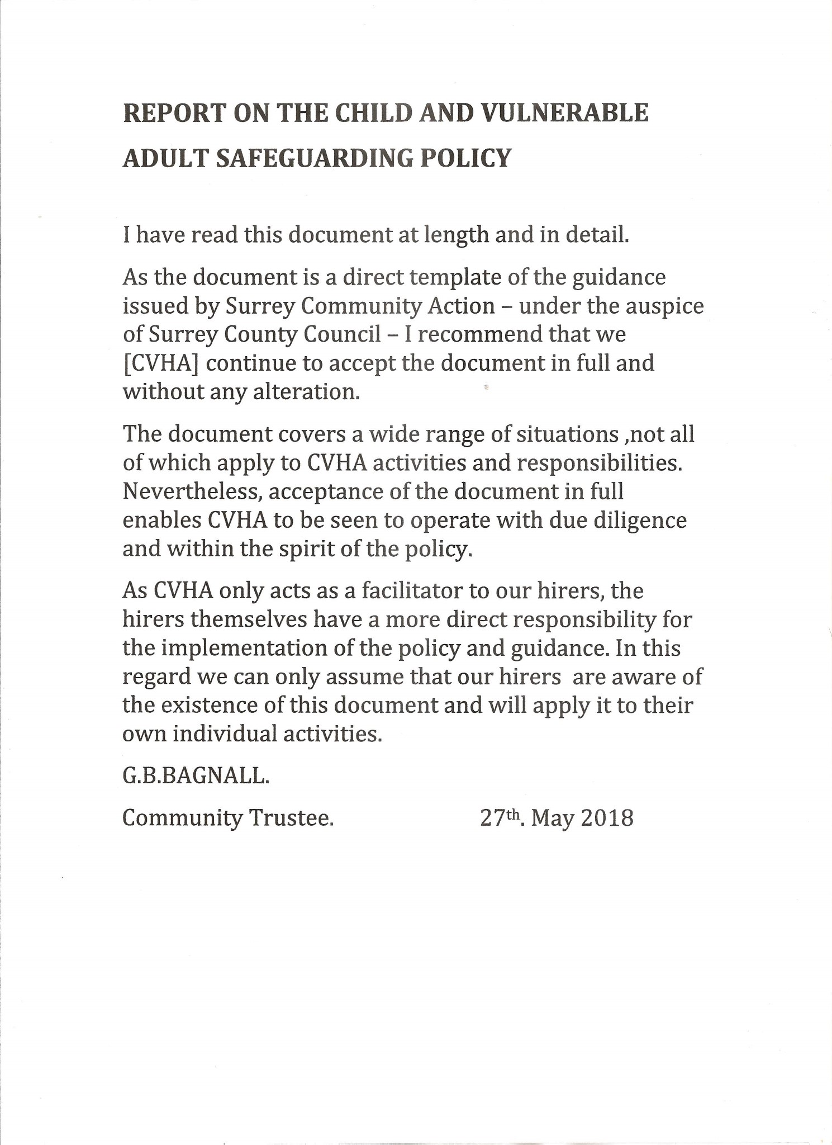
- Review Records
REPORT ON THE CHILD AND VULNERABLE ADULT SAFEGUARDING POLICY.
I have read this document at length and in detail.

As the document is a direct template of the guidance issued by Surrey Community Action – under the auspice of Surrey Council Council – I recommend that we (CVHA) continue to accept the document in full and without alterations.

The document covers a wide range of situations, not all of which apply to CVHA activities and responsibilities. Nevertheless, acceptance of the document in full enables CVHA to be seen to operate with due diligence and within the spirit of the policy.

As CVHA only acts as a facilitator to our hirers, the hirers themselves have a more direct responsibility for the implementation of the policy and guidance. In this regard we can only assume that our hirers are aware of the existence of this document and will apply it to their own individual activities.

I understand that my inspection of the document relates to the period up to 30th December 2018 and that any alterations to personnel named in positions of responsibility will be amended post-AGM.

Shirley Round
Community Trustee.

16th May 2019.

